Assignment 4

Submitted by Drishti Thakur
Roll No. 25SCS1003002554

Problem 1: Check Even/Odd and Positive/Negative
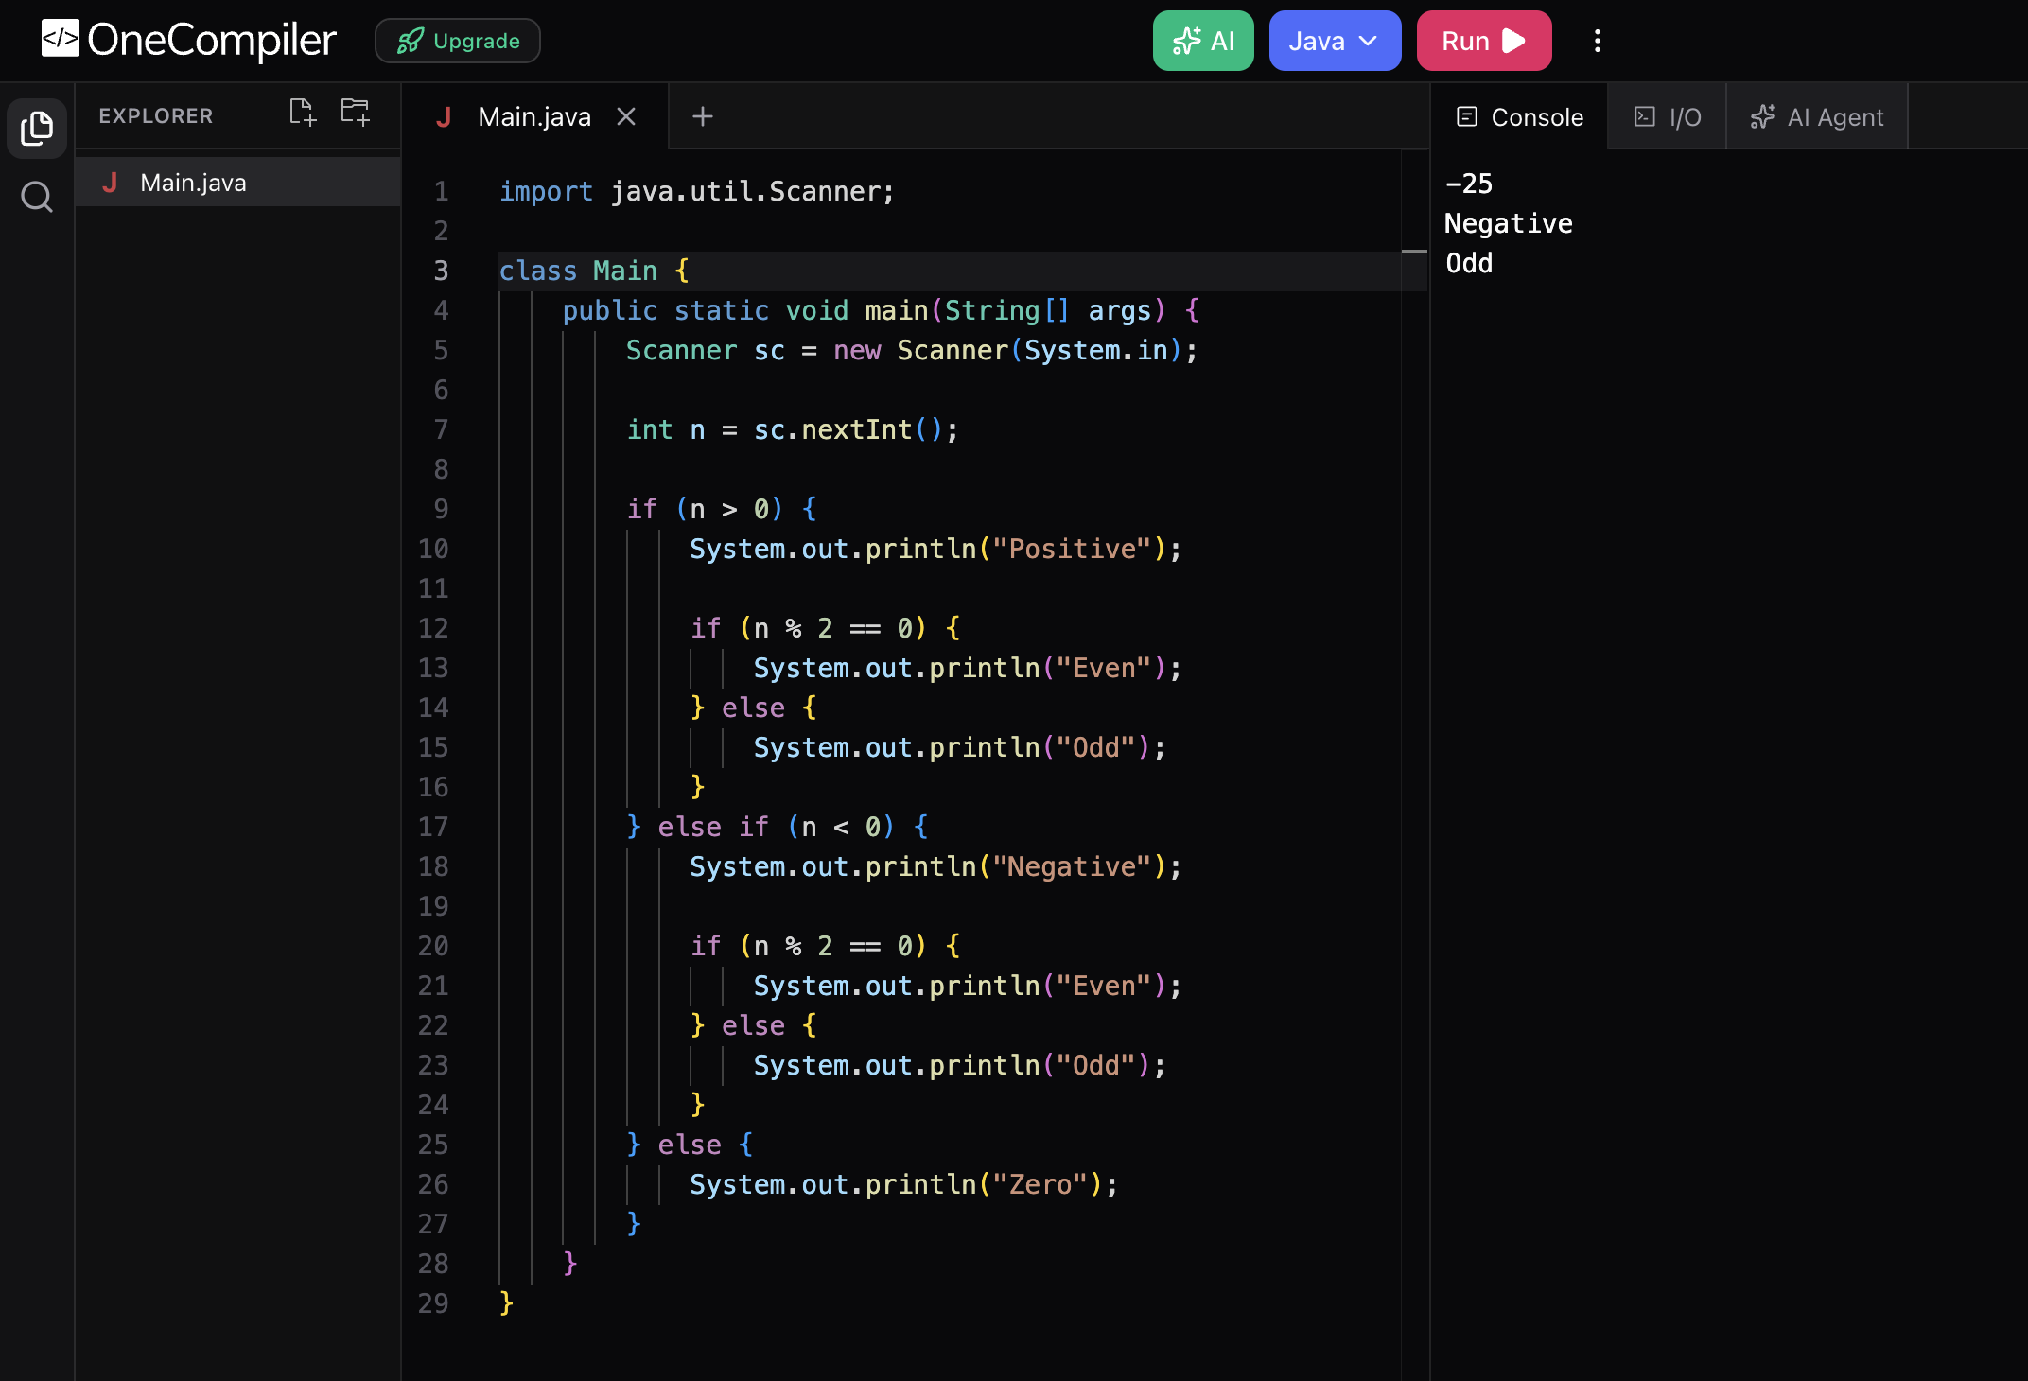

Problem 2: Largest of Three Numbers
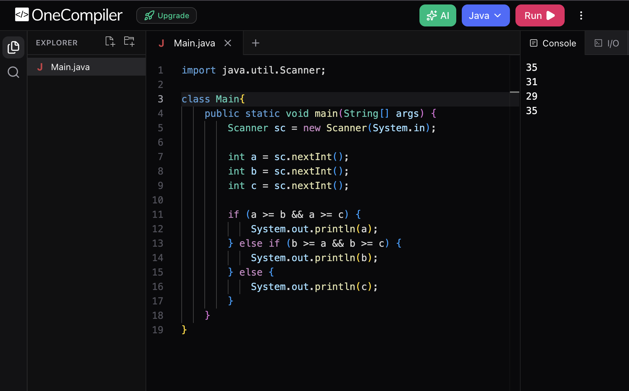

Problem 3: Number Divisibility Checker
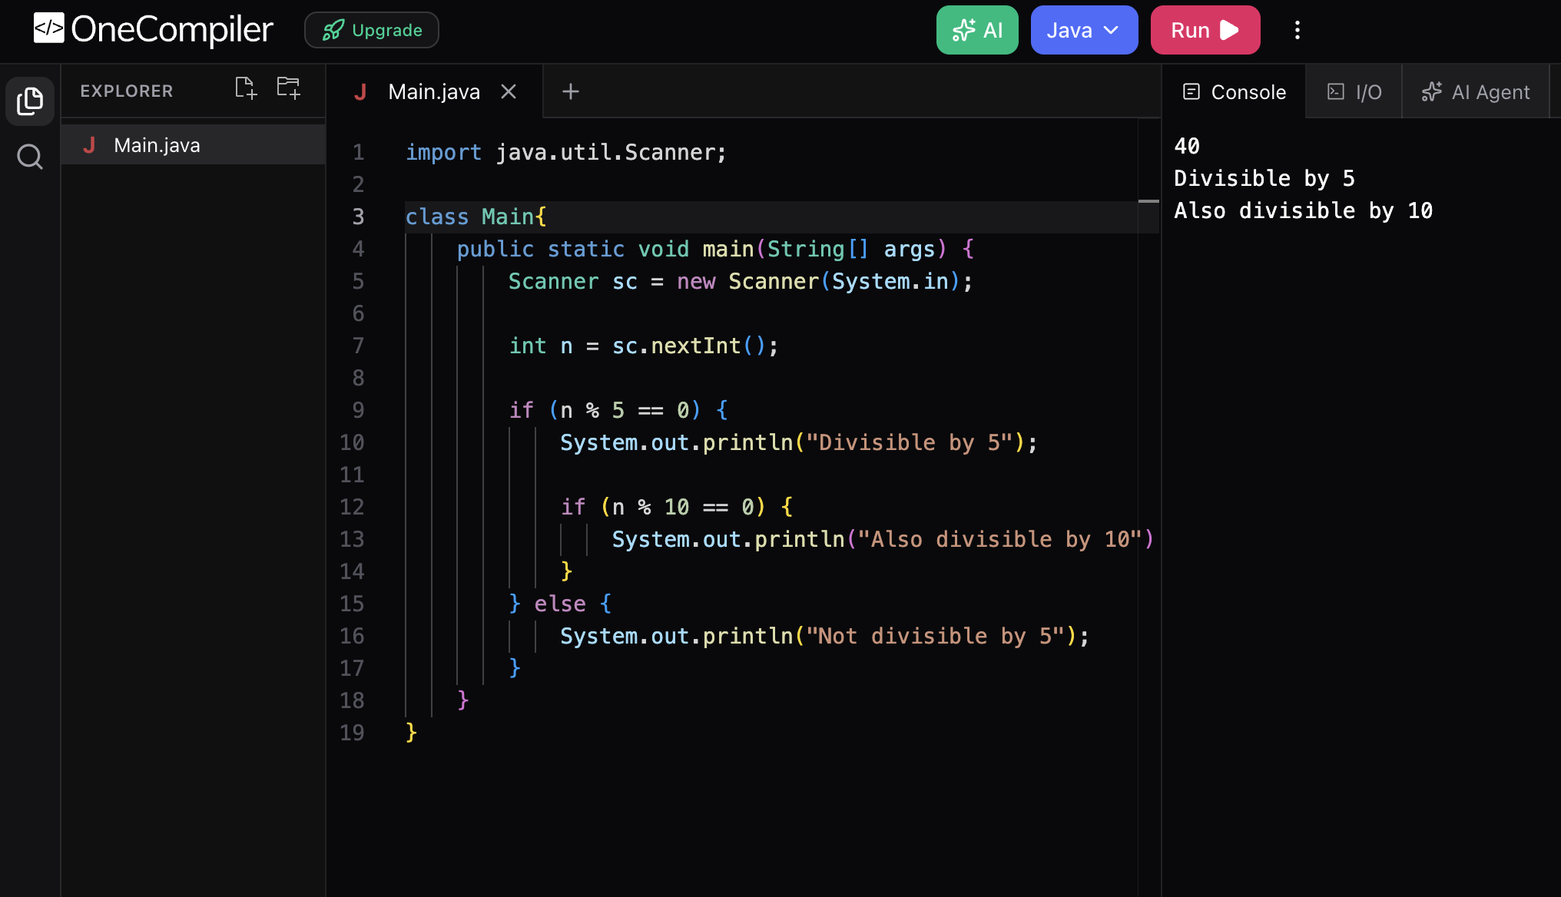

Problem 4: Check Working Day
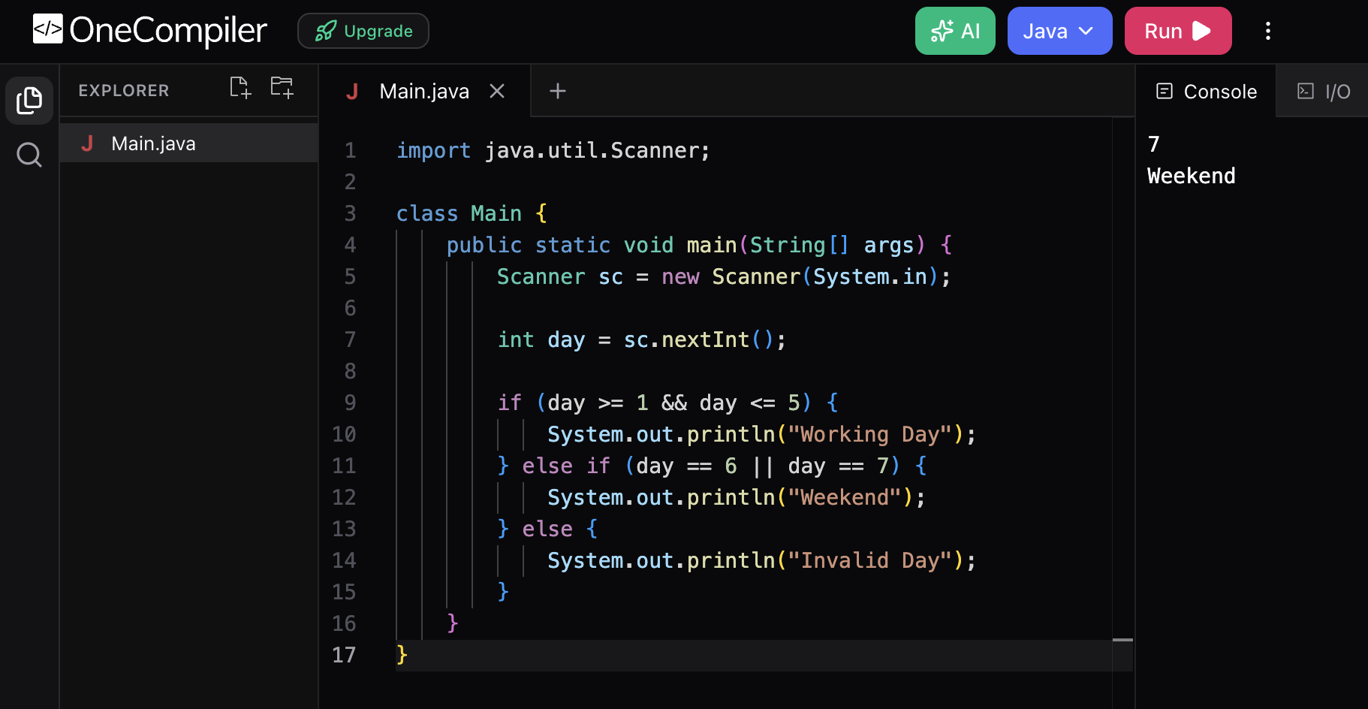

Problem 5: Password Length Checker
